**SQL DAY 5 ASSIGNMENT   
PRATIKSHA TAMBE(243072)**

player (player_id, pname, speciality, date_ofjoining, num_matches, team_id)

team(team_id, tname,player_num)

matches(match_id, team1_id,team2_id,match_date,winner,man_of_the match)

**//Team Table**

create table team(

team_id int primary key,

tname varchar(20),

player_num int check(player_num>0));

**//Player Table**

create table player(

player_id int primary key,

pname varchar(20),

speciality enum('bowler','batsman','allrounder','wicketkeeper'),

date_of_joining date,

num_matches int,

team_id int,

constraint fr_tid foreign key (team_id) references team(team_id)

on delete set null

on update cascade);

**//Matches Table**

create table matches(

match_id int primary key,

team1_id int,

team2_id int,

match_date date,

winner int,

man_of_the_match int,

constraint fk_t1id foreign key(team1_id) references team(team_id),

constraint fk_t2id foreign key(team2_id) references team(team_id),

constraint fk_mm foreign key(man_of_the_match) references player(player_id),

constraint chk_win check(winner in(team1_id,team2_id))

);

**Team**

| **team_id** | **tname** | **player_num** |
| --- | --- | --- |
| 101 | CSK | 13 |
| 102 | RCB | 15 |

**Player**

| **player_id** | **pname** | **speciality** | **date_of_joining** | **num_matches** | **team_id** |
| --- | --- | --- | --- | --- | --- |
| 7 | dhoni | wicketkeeper | 2004-02-01 | 289 | 101 |
| 18 | kohli | batsman | 2008-02-01 | 189 | 102 |
| 8 | jadeja | allrounder | 2006-10-01 | 199 | 101 |
| 19 | kartik | wicketkeeper | 2008-10-01 | 199 | 102 |

**Matches**

| **match_id** | **team1_id** | **team2_id** | **match_date** | **winner** | **man_of_the_match** |
| --- | --- | --- | --- | --- | --- |
| 1 | 101 | 102 | 2024-03-25 | 102 | 7 |
| 2 | 102 | 101 | 2023-12-31 | 101 | 8 |
| 3 | 101 | 102 | 2024-03-18 | 102 | 7 |
| 4 | 102 | 101 | 2024-03-11 | 101 | 18 |

**simple query**

1. display all players playerid, player name and experience

**select player_id, pname, date_of_joining, floor(datediff(curdate(),date_of_joining)/365) "Experience" from player;**

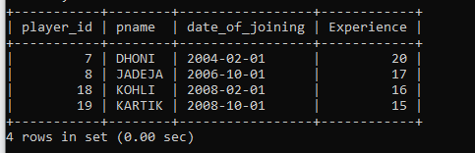

2. display all player with experience > 5 years

**select player_id, pname, date_of_joining from player**

**-> where floor(datediff(curdate(),date_of_joining)/365)>5;**

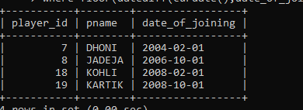

3. display all players joined in march month, any year

**select * from player**

**-> where month(date_of_joining)=3;**

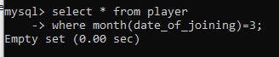

4. display all players joined in march 1995

**select * from player**

**-> where date_format(date_of_joining, '%m %Y')= '03 1995';**

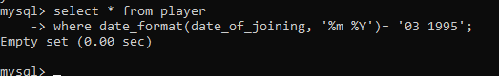

5. display all player with number of matches played are either 5 or 10 or 8

**select * from player**

**-> where num_matches in(200, 289, 199);**

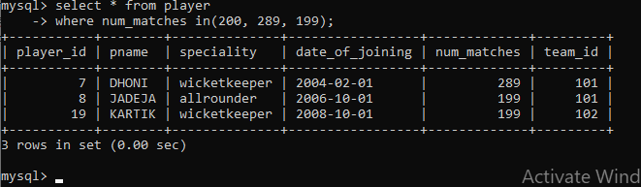

6. display all players who are either batsman, bowler

**select * from player where**

**-> speciality in('allrounder', 'batsman');**

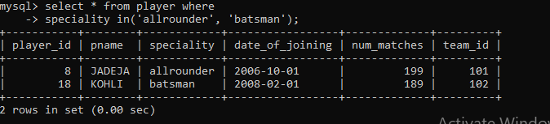

7. display all employees who joined in year 1995 or 1996 or 1997

**select * from player**

**-> where year(date_of_joining) in(2004,2006,1995);**

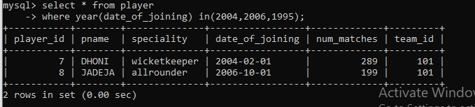

**Nested query**

1. list all player who plays in virat kohalis team

**select * from player**

**-> where team_id=(select team_id from player where pname='kohli');**

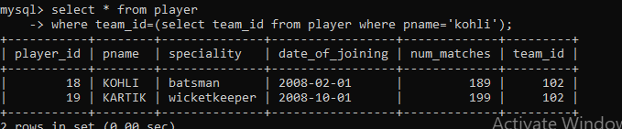

2. list all players who played matches in year 2024

**select * from player**

**-> where team_id in (select distinct team1_id from matches where year(match_date)='2024');**

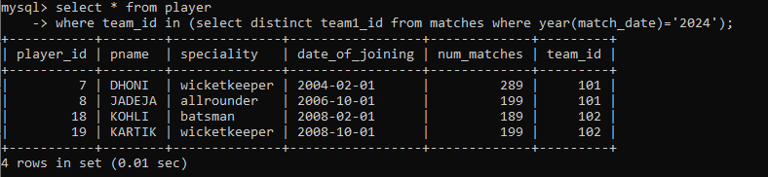

3. list all matches in which man of the match is from team1

**select * from matches**

**-> where team1_id in(select team_id from player where player_id in(select man_of_the_match from matches));**

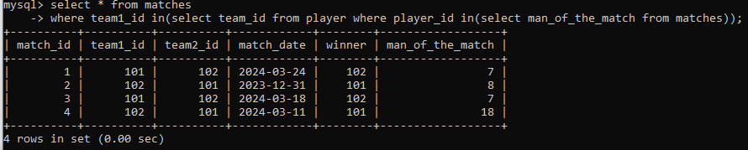

4. list all matches in which man of the match is from team2

**select * from matches**

**-> where team2_id in(select team_id from player where player_id in(select man_of_the_match from matches));**

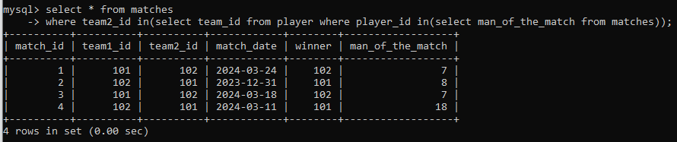

5. list all matches in which csk team win.

**select * from matches**

**-> where winner=(select team_id from team where tname='csk');**

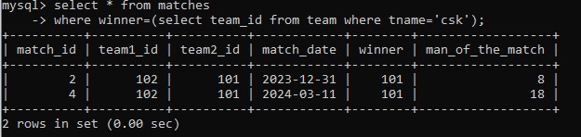

6. list all matches in which either csk or rcb team won the match

**select * from matches**

**-> where winner in ((select team_id from team where tname in('csk')),(select team_id from team where tname in('rcb')));**

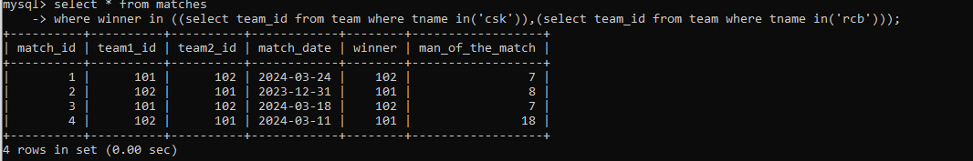

7. list all teams who won atleast one match

**select * from team t**

**-> where exists(select * from matches m where m.winner=t.team_id);**

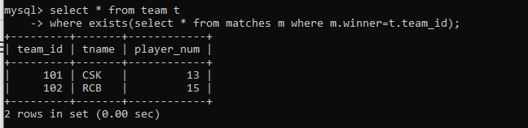

8. list all teams who does not played any match

**select * from team t**

**where not exists(select * from matches m where m.winner=t.team_id);**

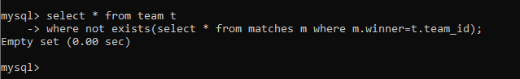

9. list all team name, in which no players are their

**select * from team t**

**where not exists(select * from players p where t.team_id=p.team_id);**

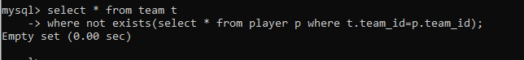

10. list all players who are in dhoni’s team

**select * from player p**

**-> where exists(select * from player m where p.team_id=m.team_id and m.pname='dhoni');**

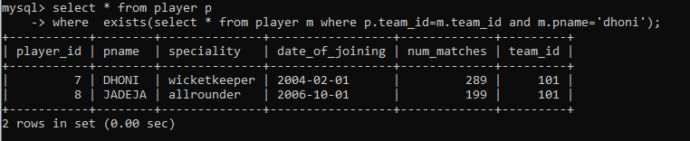

11. list all players who are in either dhoni’s or virat’s team

**select * from player p**

**-> where exists(select * from player m where p.team_id=m.team_id and m.pname in('dhoni','kohli'));**

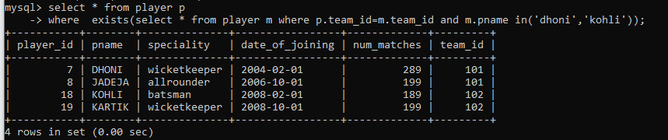

12. find all team names who won more than 3 matches